
MATHEMATICS APPLICATIONS
Test 4 2018 Statistics
Section A-Resource Free
Marks: 20 Time Allowed: 20 minutes

TOTAL : 57 Name: _______________
ALL working must be shown for full marks.
For any answers that do not exist an explanation must be given.

Question 1 [4 marks]
- Classify the following data by placing it into the correct section of the table:

Times recorded in a running race, car colours, baby weight, gender, hotel star rating, number of goals kicked in a football game, report grades, height, language spoken at home.

Categorical |  | Numerical
Nominal | Ordinal | Discrete | Continuous

Question 2 [4, 4 = 8 marks]
Calculate the mean, median, mode and range for the following sets of data.
- 3, 7, 10, 3, 11, 0, 6, 8

- 1 3, 6
2 0, 4, 7
3
4 0, 9
5 1, 2, 8

Question 3 [3, 5 = 8 marks]
- Given the set of nine scores below, give a possible value for a 10th score x if it is a maximum score and an outlier. Justify your answer by showing all calculations.

16, 5, 7, 3, 12, 20, 16, 11, 2, x

- Describe how removing the outlier above will affect the
- Mean

- Median

- Mode

- Standard deviation

- Range


MATHEMATICS APPLICATIONS
Test 4 2018 Statistics
Section B-Resource Assumed
Marks: 37 Time Allowed: 35 minutes

ALL working must be shown for full marks.

Question 1 [1, 2, 5, 4 = 12 marks]
The following dot plot represents the number of pizza slices eaten per person at a teenager’s
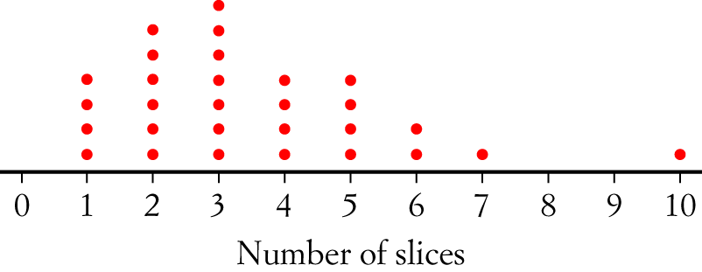
16th birthday.

- What is the total number of pizza slices consumed?

- Is 10 an outlier? Explain.

- Ignoring any outliers, calculate the Mean, Mode, Median and Range and Inter Quartile Range for the number of slices of pizza eaten.

- Create a Box and whisker graph below using the statistics in part c)

Question 2 [ 3, 2, 1 = 6 marks]
The sixty Mathematics students at City Senior High School sat for a Data Analysis test.
The table below shows the results on the test, which was marked out of 50.

Marks (x) | Number of students (n
10 x < 20 | 26
20 x < 30 | 19
30 x < 40 | 11
40 x < 50 | 3
x50 | 1

- Plot this information as a histogram on the grid below.
- Use a horizontal line to show the location the Mean and Median on the histogram below.

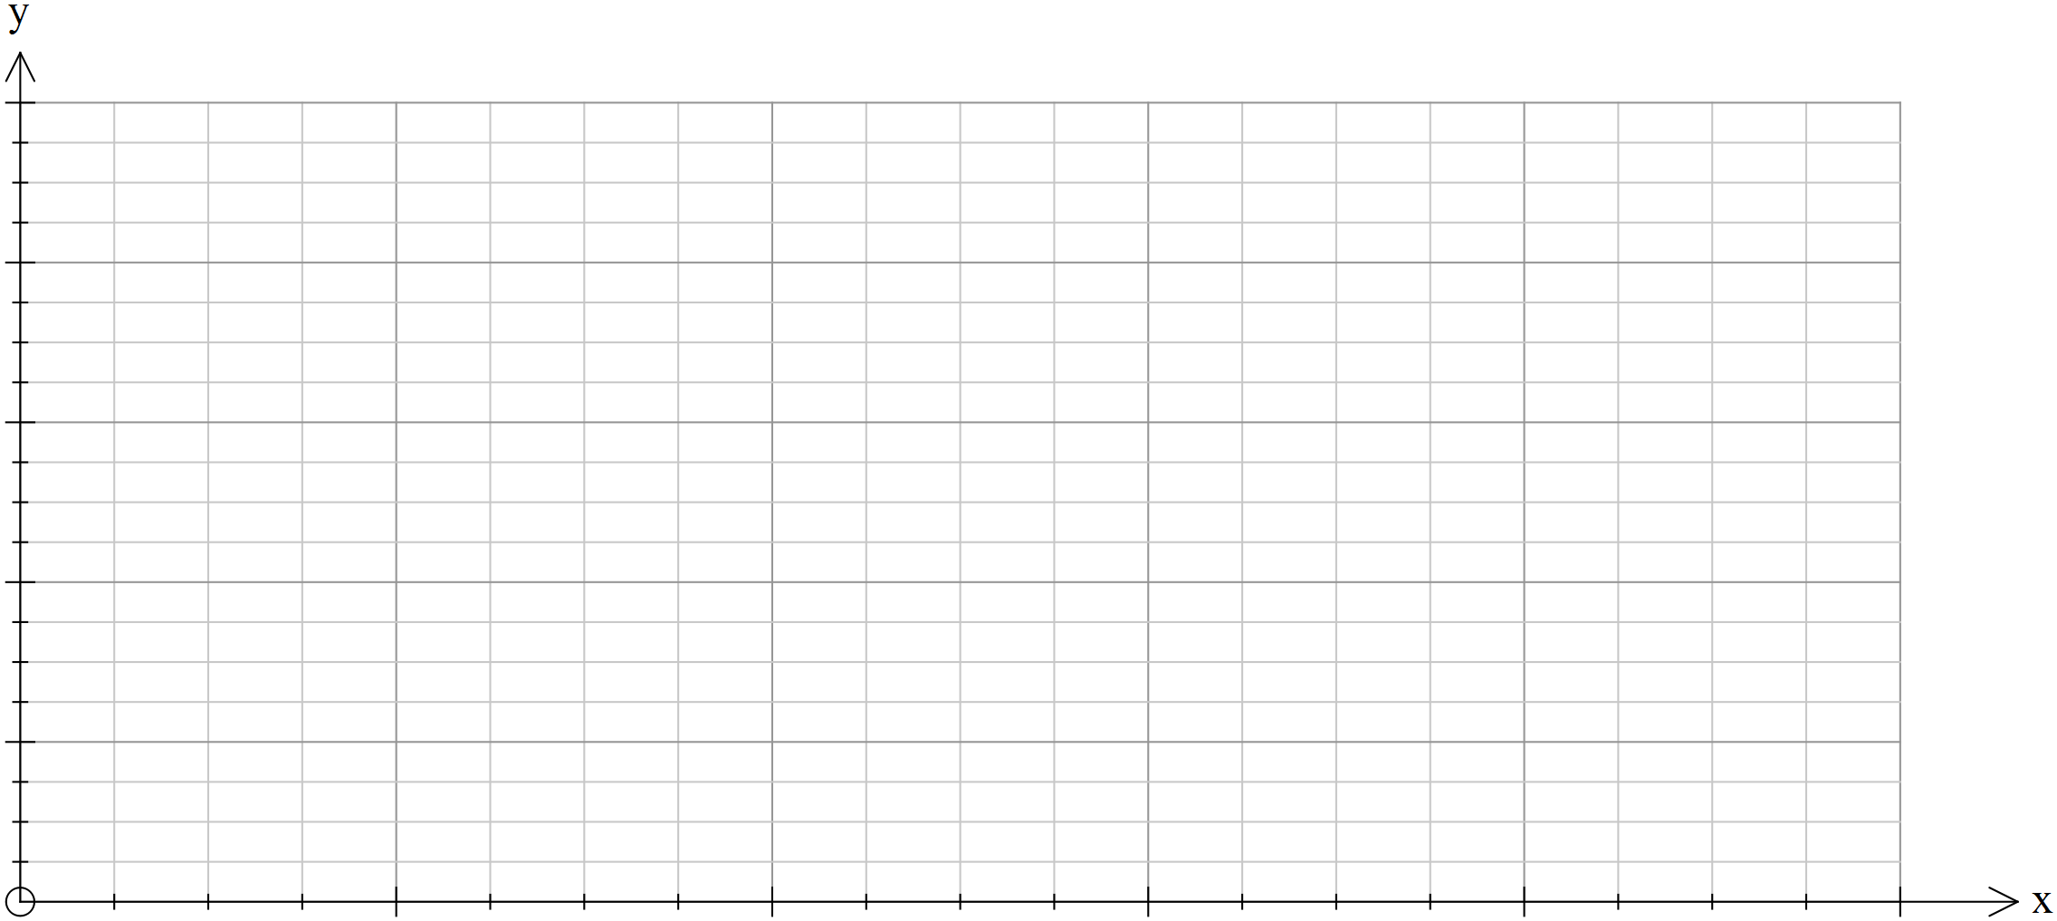

- Describe the shape of the histogram you have drawn.

Question 3 [1, 1, 1, 2 = 5 marks]
The following boxplot shows the amount of pocket money ($) children were paid per month.
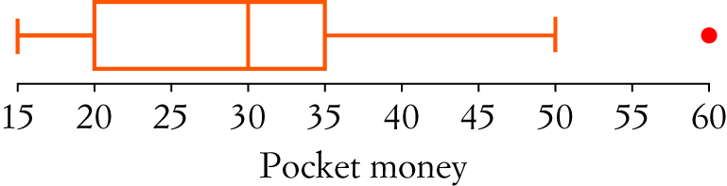

- What is the median pocket money paid?

- What percentage of children were given pocket money of $35 dollars or less?

- What is represented by the dot at the end of the graph?

- Describe the data found in the box plot.

Question 4 [4 marks]
The scores below are in ascending order and have a median of 26, a range of 38 and an interquartile range of 28. Find the values of a, b and c.

a, 6, 10, 22, b, 28, c, 38, 40.

Question 5 [5, 3, 2 = 10 marks]
The data below shows the English essay results out of 50 for two different classes.
- Calculate the mean, mode, median, IQR and standard deviation for each class.

Class A Results | Frequency
20-29 | 4
30-39 | 5
40-49 | 6
50-59 | 5
60-69 | 5
70-79 | 3
80-89 | 4
Class B Results | Frequency
20-29 | 2
30-39 | 1
40-49 | 7
50-59 | 11
60-69 | 10
70-79 | 0
80-89 | 1

Mean: Mean:

Mode: Mode:

Median: Median:

IQR: IQR:

St Dev (s_{x}) : St Dev (s_{x}):

- Comment on the results for each class and how they compare.

- Calculate the mean and standard deviation for the combined group A and B and use the information below to calculate the number of A’s and B’s for the combined group.

A- given to any mark 1.5 standard deviations above the mean.
B- given to any mark between 0.5 and 1.5 standard deviations above the mean.
C- given to any mark between 0.5 standard deviations above or below the mean.
D- given to any mark between 0.5 and 1.5 standard deviations below the mean.
E- given to any mark 1.5 standard deviations below the mean.

